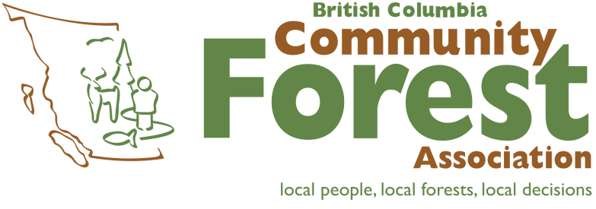

Strategic Plan
2018-2021
May 2018

Table of Contents
Introduction 3
Definitions 3
Foundation Statements 3
Areas of Focus, Goals and Objectives 3
Foundation Statements 4
Mission 4
Purposes 4
Vision 4
Value Statements 4
Areas of Focus, Goals and Objectives 5

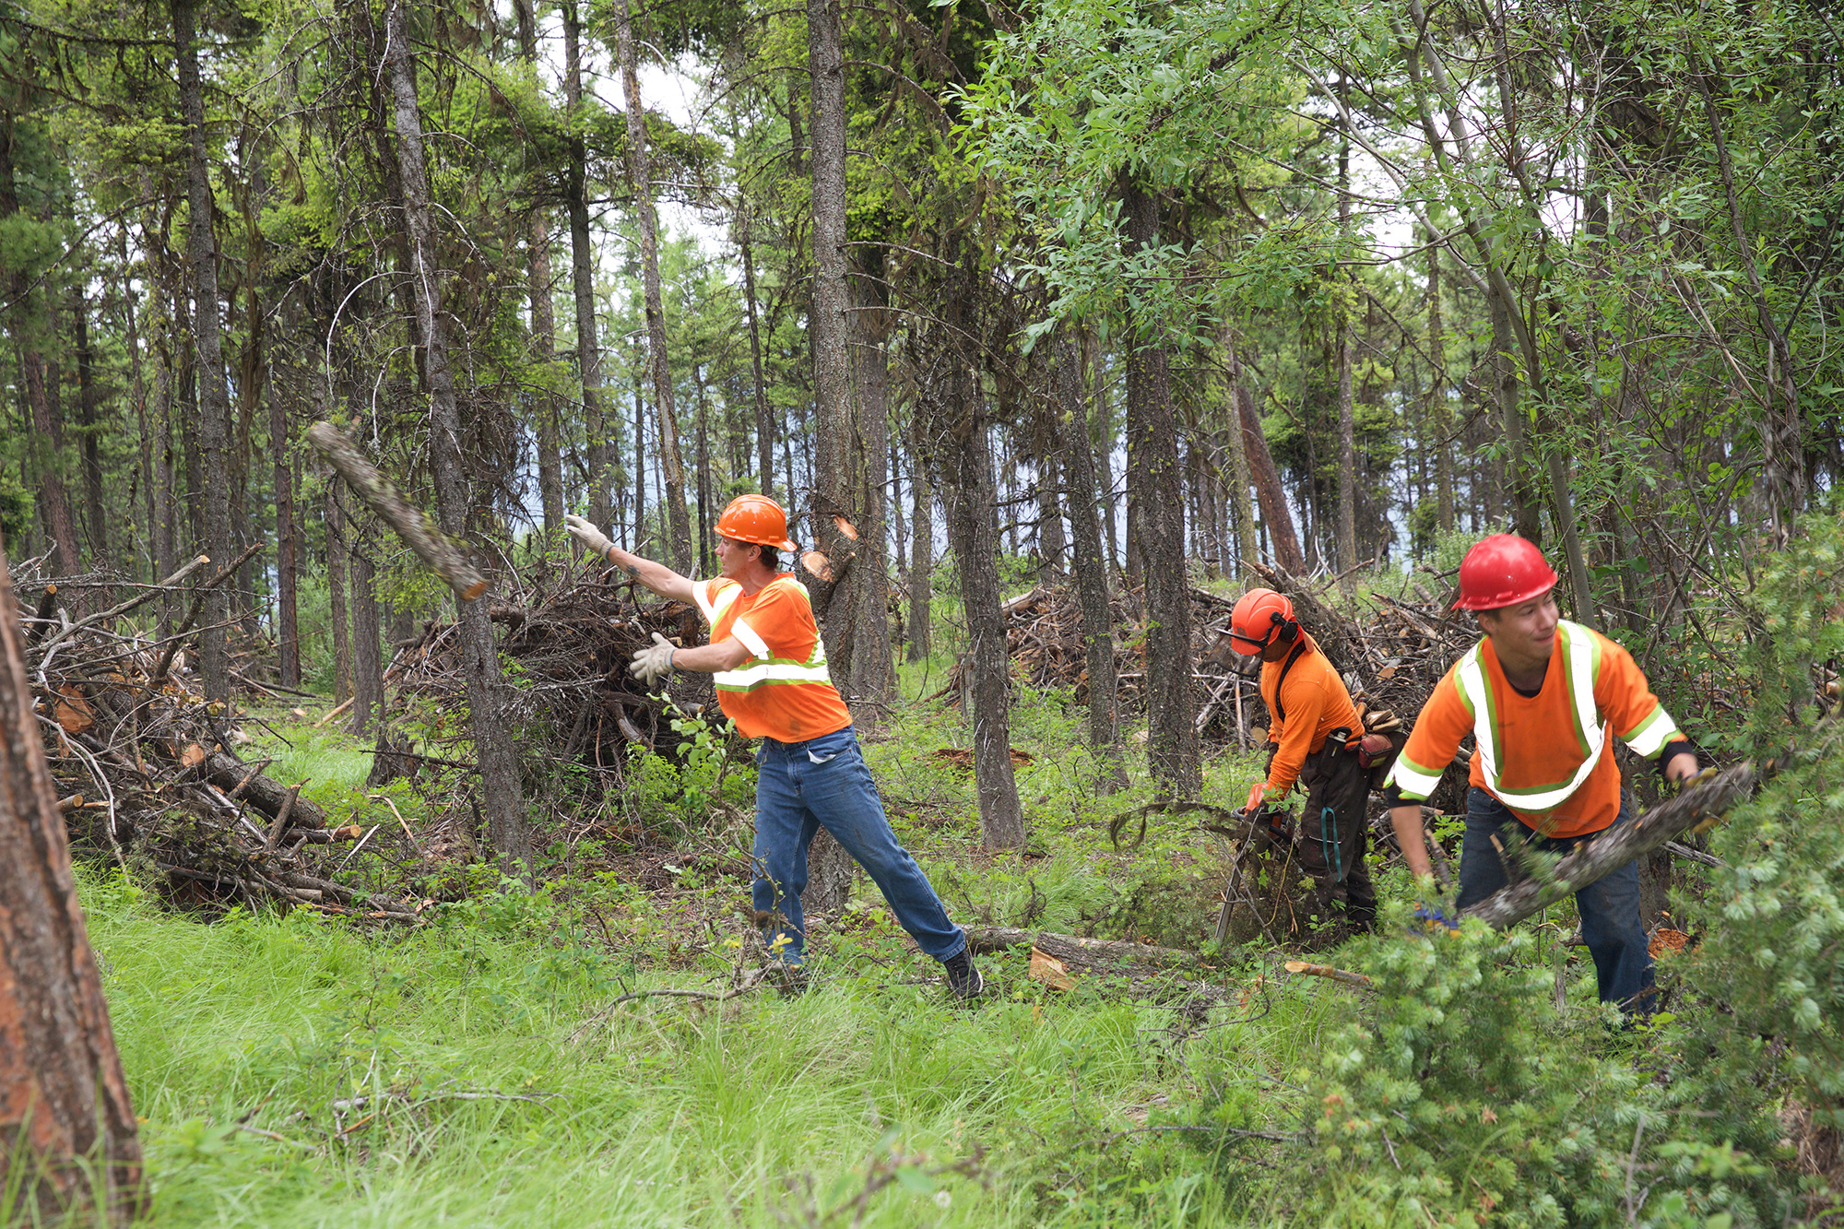

Introduction
From humble beginnings in 2002 with only 10 member communities, the BC Community Forest Association (BCCFA) has become a respected organization, representing the interests of communities all over BC. Sixteen years since our formation, the BCCFA is 54 members strong. The members represent over 90 rural and Indigenous communities across our province. We share a vision of a network of diverse community forest initiatives, where local people practice ecologically responsible forest management in perpetuity, fostering and supporting healthy and vibrant rural communities and economies.

Definitions

Foundation Statements

Mission Statement: This statement describes the overall purpose of the organization. It sets the boundaries of the organization’s activities and is the starting point for developing a strategic vision.

Purposes: These provide more specific detail on the work of the association, and together comprise the Association’s Constitution.

Vision: This statement describes an ideal future, and answers the question: What impact do we want to have on society? Our vision includes a set of principles that provide a framework to guide our decision-making and actions.

Value Statements: These reflect the core ideology of the Association and answer the question: How do we carry out our mission?

Areas of Focus, Goals and Objectives

Focus Areas: These are the priority headings, or areas of emphasis, under which the strategic goals and objectives of the Association are organized.

Goals: Each focus area has a related goal. It is the vision statement for the focus area.

Objectives: These are the desired result of each goal and are stated as measurable outcomes.

Foundation Statements

Mission
Our mission is to promote and support the practice and expansion of sustainable community forest management in British Columbia.

Purposes
Please note that the sections highlighted in yellow below will be presented to the membership at the 2019 AGM for consideration as a change to the purposes of the Society through a special resolution
The purposes of the Association are to:
- Work to ensure the viability of community forest initiatives
- Provide education on community forestry issues
- Assist community forest practitioners in accessing resources required to succeed
- Promote community forestry as a strategy for community economic development

The BCCFA Board proposes the stated purpose be changed to:

Promote community forestry as a strategy for forest ecosystem resilience and community economic development.

Vision
Our vision is a network of diverse community forest initiatives, where local people practice ecologically responsible forest management in perpetuity, fostering and supporting healthy and vibrant communities and economies.

To achieve this vision, the Association will be guided by principles that promote:
- Culturally, ecologically, and economically sustainable community forest initiatives in a manner which respects Indigenous rights and cultural values, and which fosters understanding and cooperation between Indigenous and non-Indigenous communities.
- Resilient forest ecosystems as a basis for social, ecological and economic health.
- Meaningful representation of community members in community forest initiatives.
- Informed public participation in community forest decision-making.
- Leading edge forest practices.
- Safe work practices.
- Local forest-based employment.
- Community responsibility for land stewardship.

Value Statements
The values that guide our organization:
- Decision-making that respects the unique approaches, diversity, opinions and values of our members.
- Open, honest, accountable, and transparent communications with our community members, partners and all stakeholders.
- Professional standards of excellence in all aspects of personal, board, staff and organizational governance.
- Acting as one voice to represent the interests of our membership.
- Leading by example and being accountable for our actions, successes and failures.

Areas of Focus, Goals and Objectives
The priorities for the BCCFA are categorized into following five key Areas of Focus:

- External Relations and Government Policy
- Membership
- Indigenous Relations
- Education
- Operations and Governance

Area of Focus | Goal | Objectives
External Relations and Government Policy | BCCFA objectives are reflected in the policies and decisions of government, and are supported by industry associations, non-governmental organizations and academic institutions. | - Tabular rates for sawlog stumpage are in effect, or a better timber pricing arrangement for Community Forest Agreements has been implemented.  - Government supports the implementation of policy changes recommended by the BCCFA.  - There are 6 new CFAs with First Nations Partners.  - The provincial government states its intention to increase the number and size of community forests, articulating a vision to make them available in the long-term to all communities that can demonstrate capacity and commitment to the Provincial Goals of the community forest program.  - BCCFA has a strong and supportive working relationship with other associations, organizations and institutions.  - Community forests are funded and part of Provincial planning efforts to create fire adapted communities and fire-resilient ecosystems and landscapes.
Area of Focus | Goal | Objectives
Member Services | Community Forest Organizations have access to the resources they need to be successful and have a resilient land base. | - BCCFA members are informed about opportunities to develop innovative business relationships.  - Collaborative relationships have formed among BCCFA members.  - 6 partnerships have been formed among CFAs to pool resources on a business activity or project.  - Federal and Provincial Wildfire management and community economic development funding directly available to community forests has increased and the administrative process has been streamlined.
Indigenous Relations | Community Forest organizations invest time, resources, and personal effort to build effective relationships and partnerships between First Nations and non-Indigenous communities. | - Members are informed about the Indigenous history and culture of the land they are managing.  - Community forest management decisions consider both scientific technical knowledge and Indigenous traditional knowledge.  - Members share information and communicate openly, transparently and in a timely manner.  - Members have knowledge of the UN Declaration on the Rights of Indigenous People and apply the principles in their work with local First Nations.
Education | British Columbians are knowledgeable about community forestry, and the benefits that community forests bring to communities in BC. | - MLAs, mayors and local governments speak in an informed and positive way about community forests.  - There is broad public support for community forests.

Area of Focus | Goal | Objectives
Operations and Governance | BCCFA board and staff demonstrate professional standards of excellence and accountability in all aspects of personal, board, staff, financial and organizational governance. | - Our revenue streams fully fund our plans and operations.  - BCCFA is operating with a fully functioning and effective policy focused board.  - 100% of issued CFAs are members of the BCCFA and are paying their dues.  - Our members annually indicate that BCCFA membership is good value.

British Columbia Community Forest Association
130 Government Street
Victoria, BC V8V 2K7
Tel: (250) 384-4110
www.bccfa.ca

