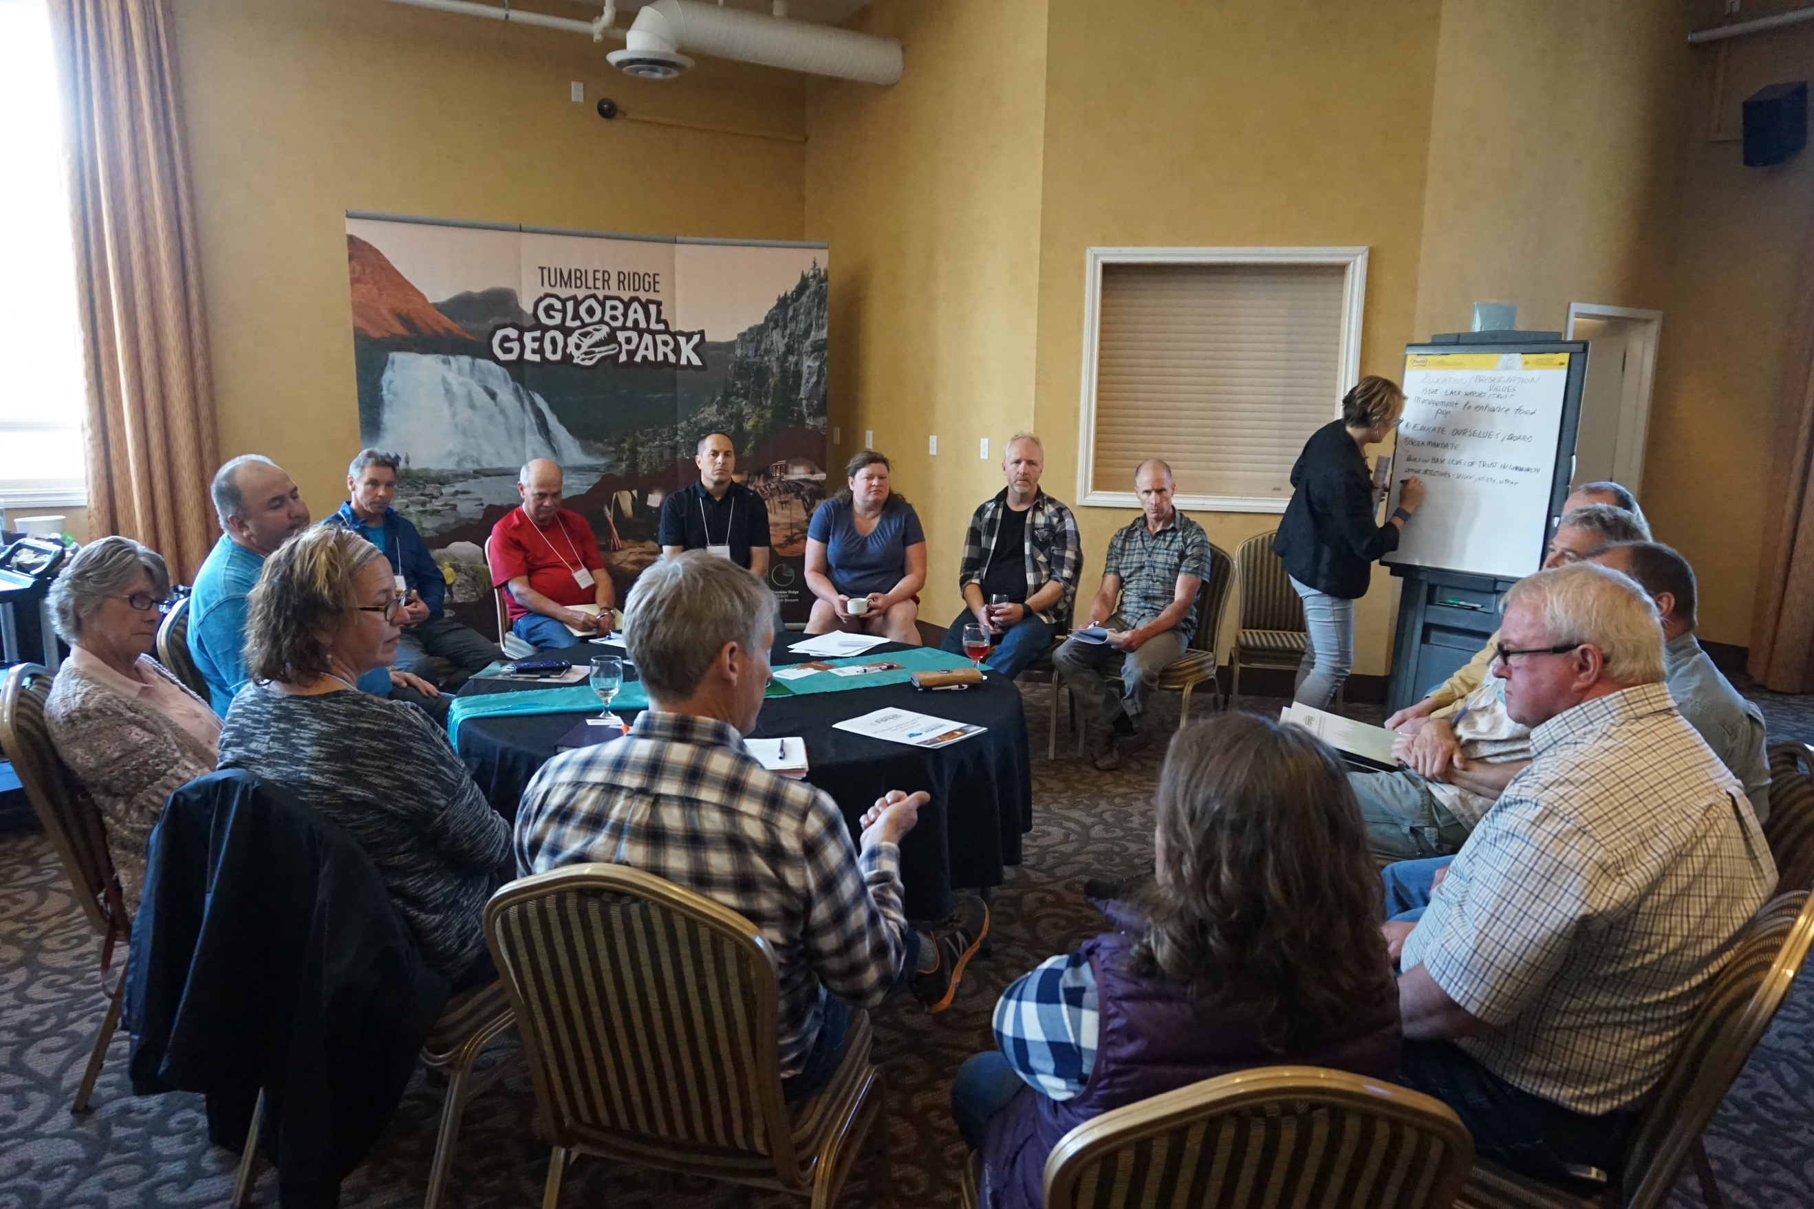
A breakout group discusses how to deal with poor community support during the Social License workshop.

“Engage/consult early with stakeholders and First Nations. Identify key contacts”

“Adapt your management plans using public input”

“If you say you’re going to do something, follow through and do it”

Management Tips
- Educate yourselves and the Board
- Seek mandate
- If possible, structure your board to encompass a wide range of knowledge
- Get to know your interest groups. Understand what they value, identify who to talk to and report to.
- When are groups consulted? Leaving consultation too late risks credibility and trust.
- Address legacy problems and misinformation; admit to your own mistakes
- Report backs to community members are critical, and these can be done through meetings in community halls (free food always brings people out), invitations to the office, taking people interested out on field trips, etc.
- Educate, adapt management, and adjust operations

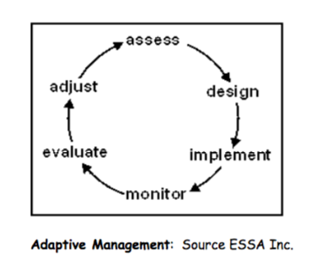

Tools
These tools, among many others, can be used to cultivate and maintain social license:
- Sustained credibility
- Consistent message
- Communication strategy
- Science, or professional opinions
- Mediation

Suggestions for BCCFA
- Continue sharing success stories from across BC
- Create a database or forum of knowledge so that we can see who has encountered similar issues, so that I can contact that person and learn about the best approach (“A telephone call can save me $10,000”). Susan already is facilitating this with knowledge in her head – possible to make it public access?
- Add a “Social License” chapter in Community Forest Guidebook
- “Engagement Toolkit” could be useful to provide steps, guidance, measures, approaches, and methods in engaging communities.

Wildfire Management Example
One group recorded multiple suggestions for a wildfire management approach to community engagement
- Local Wildfire Protection Plan ID’s high risk areas – so take the areas and show the community what you are going to do there
  - Consider computer modelling of different treatment options on an area
  - Use examples from previously treated areas
  - Use social media to circulate plans and monitor comments. Use this opportunity to clarify misunderstandings/misconceptions
  - Options for burning slash vs chipping etc. Contractor can choose
  - Timing of burning for lowest impact on wildlife, smoke concerns
  - Do what you say you will do; build trust by doing what you said
  - Overstate impacts rather than under, and give yourself a margin
  - Be as specific as possible about timing to reduce alarm
  - Engage local Fire Department to be on the ready
  - Notices on trails
  - Do small projects to gain trust
  - Allow for creation of new opportunities for recreation post-treatment – biking, skiing, etc.
  - Engage risk management experts
  - POD – get properly located. Requires getting out there with landowner or water user
- “Here is my plan…”
  - This is a draft, our ideas, proposals, interests and thoughts. What are your thoughts?
  - Do NOT simply decide and defend
  - Here is the risk we see, here are our goals, here are our tools

Prepared by George Van, The Firelight Group
http://www.thefirelightgroup.com/

